***Mid-Tidewater Baptist Association***

*Fall Meeting*

***October 20, 2019***

***MTBA 60th Anniversary***

***Program and Book of Reports***

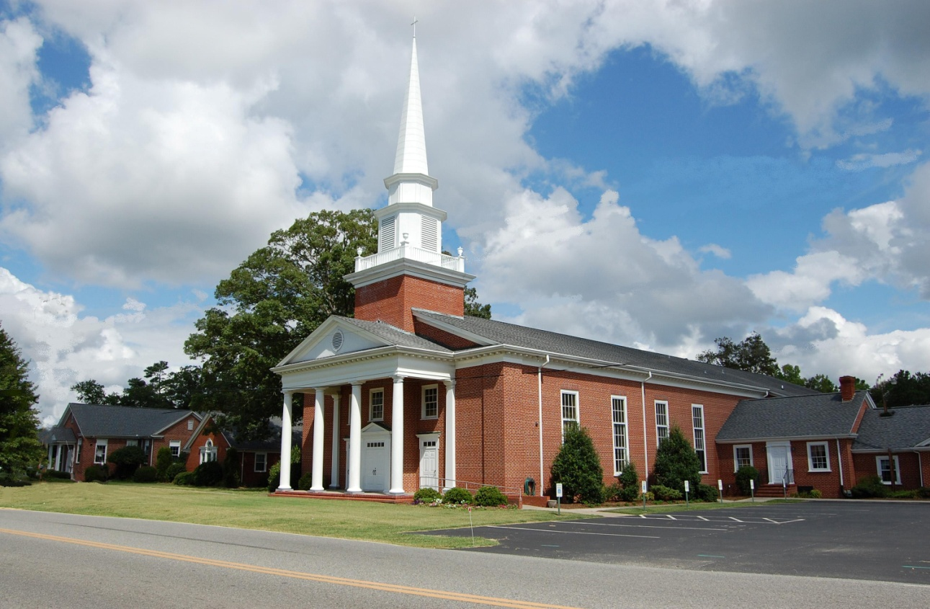*Newington Baptist Church*

(constituted in 1873)

“As you come to him, the living Stone rejected by humans but chosen by God and precious to himyou also, like living stones, are being built into a spiritual houseto be a holy priesthood, offering spiritual sacrifices acceptable to God through Jesus Christ.” I Peter 2: 4-5